CN7050- Intelligent Systems Module
Student ID: 3059676
Name: Mann Shrestha

Part I: A Multi Model Interactive Agent with Text and Image Generation
capabilities.
Task 1: Account & API key
1and 2. Sign in to Google AI Studio (Gemini developer console) and Create an API key (Gemini Developer API)
- I have created a Gemini account and API key from the given instruction in the tutorial 5.
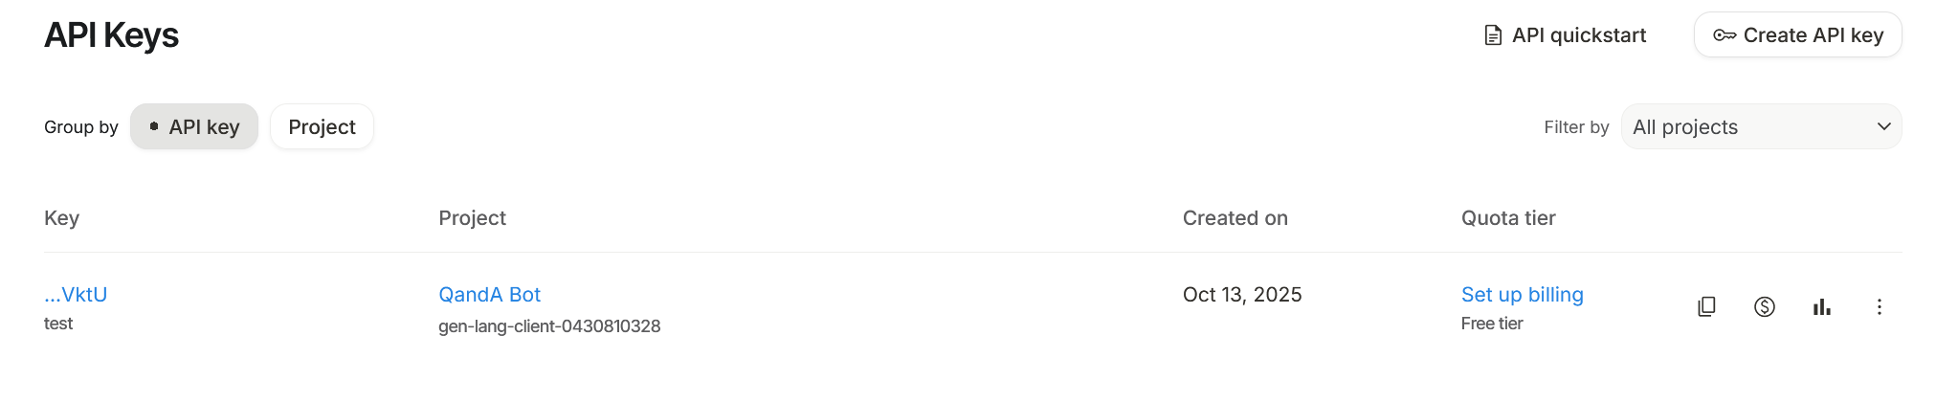
3. Hugging Face API:
- Similarly, I have created a hugging face account to access an API following the instruction in the tutorial 5.
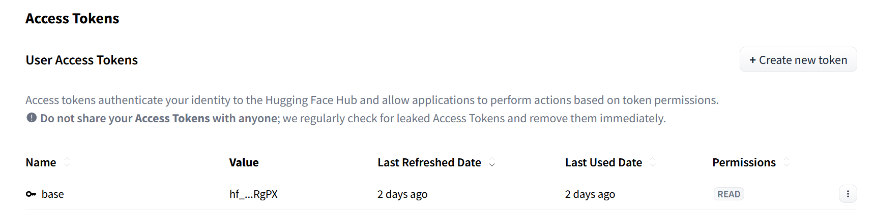
4. Open a new Google Colab notebook
5. Install the Google Gen AI SDK + helper libraries.
- I am using upgradeable version of google-genai – provides an interface to integrate Google’s generative models into python application.
- Request: HTTP library to send HTTP1.1 requests extremely easily. Such as PUT and POST data.
- Pillow: The Python Imaging Library adds image processing capabilities to our Python interpreter.
6. Securely provide your API keys in Colab
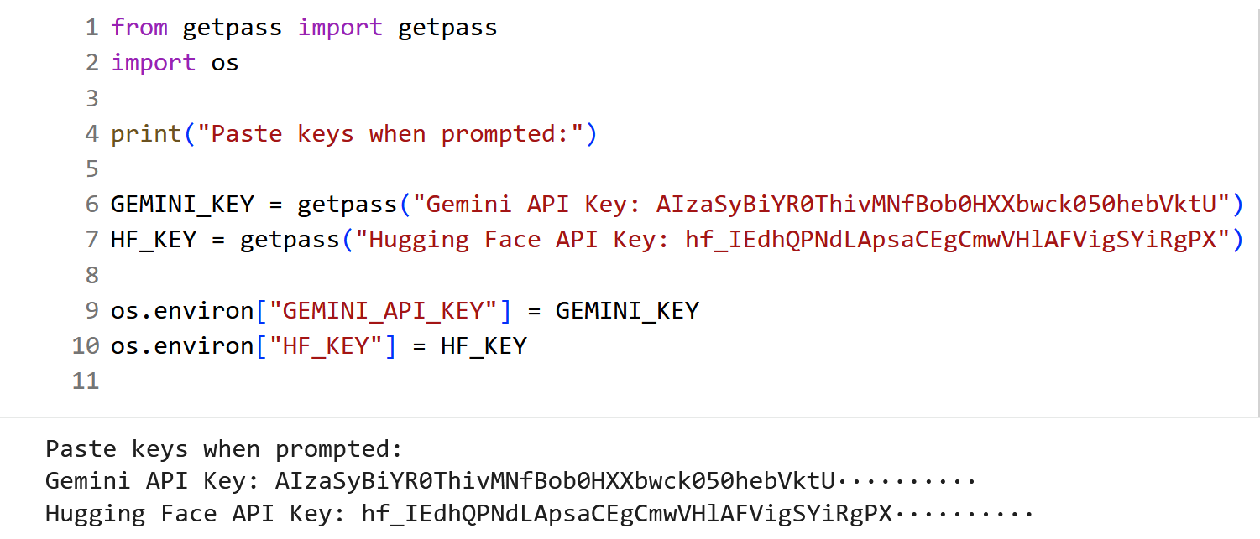
- We use getpass() module to securely handle the password prompt where programs interact with the users via the terminal.
7. Hugging Face Image Generation function.
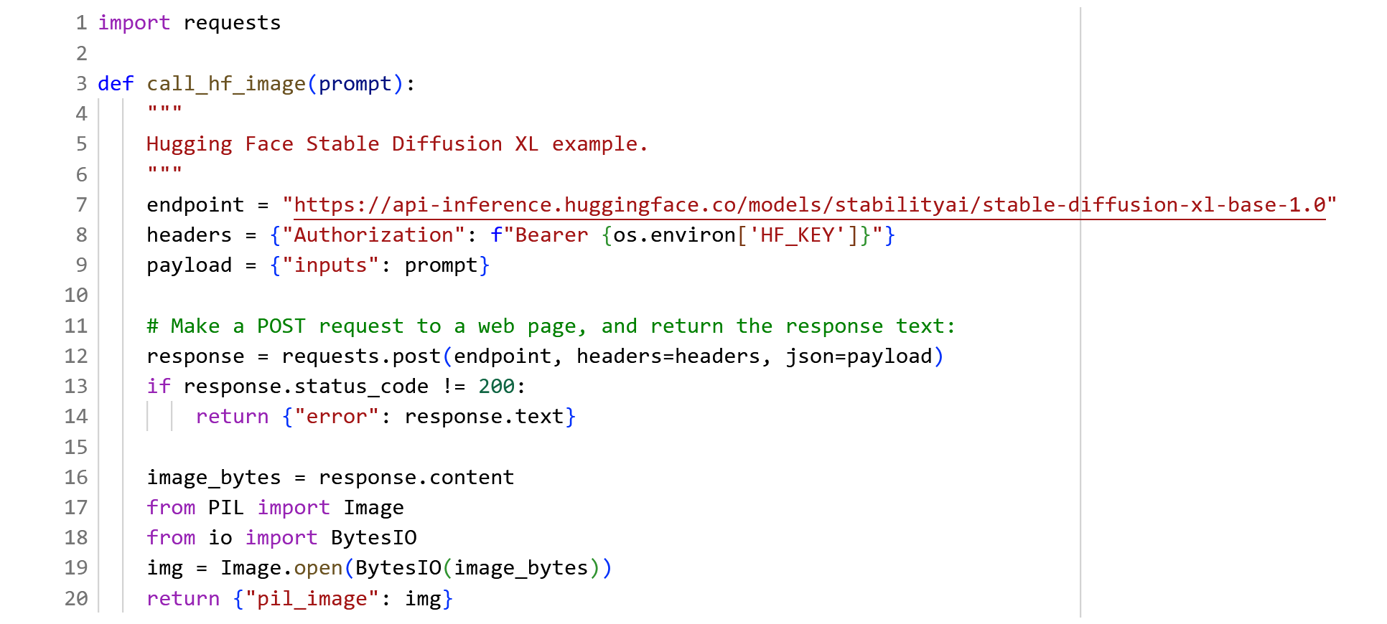
- Create a function to call hugging face API to generate image through prompt.
- I am using hugging face stable-diffusion-xl-base-1.0 model. It is developed by Stability AI. It is a diffusion model based on text-to -image generative model that uses two fixed, pretrained text encoders.
Source: https://huggingface.co/stabilityai/stable-diffusion-xl-base-1.0
- As for the BytesIO also called buffered I/O, expects bytes-like objects and produces bytes objects. No encoding, decoding, or newline translation is performed. This category of streams can be used for all kinds of non-text data, and also when manual control over the handling of text data is desired.
Ref. https://docs.python.org/3/library/io.html

8. Imports + Gemini client initialization.
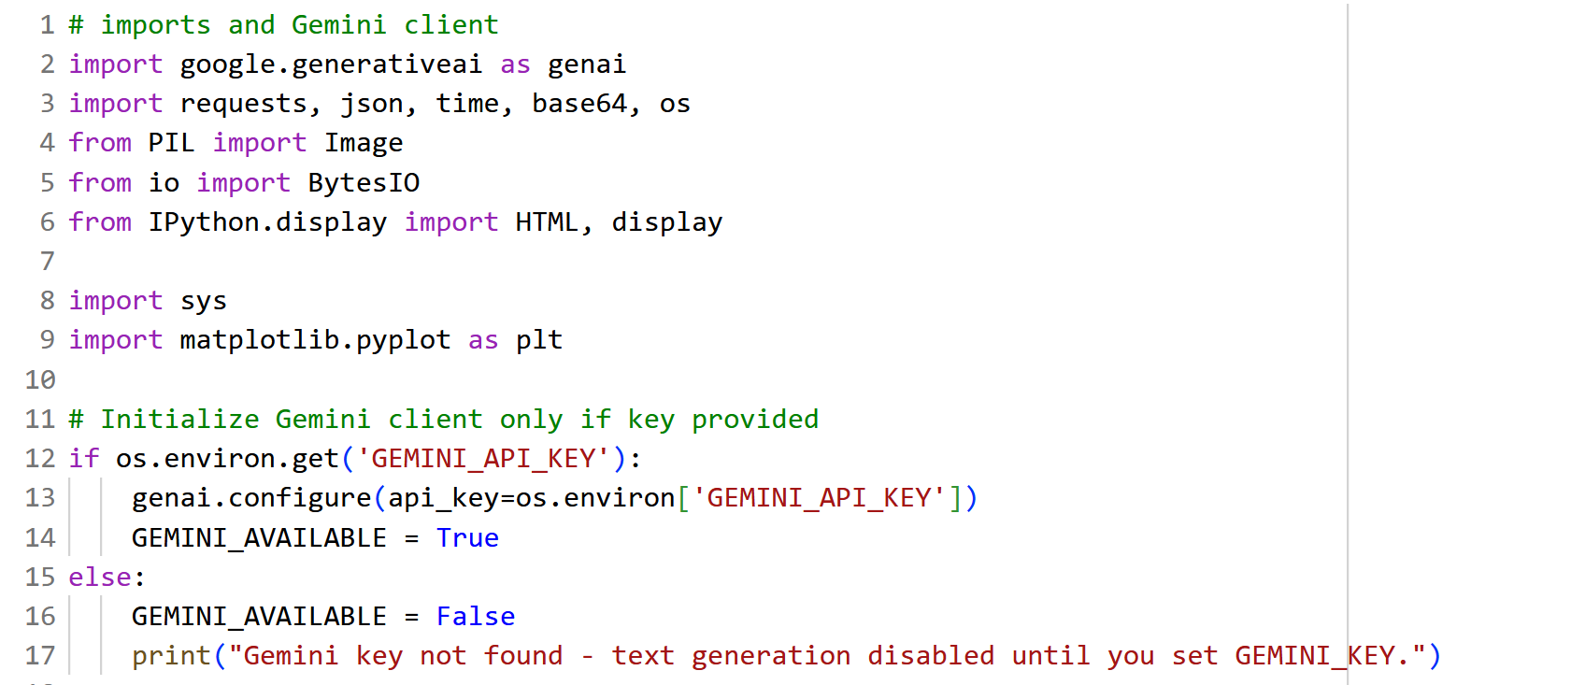
- Importing necessary libraries and initialize the Gemini client.
- Verify If Gemini key is not found, we will see the error message shown in the last code line.
9. Gemini text generation function.
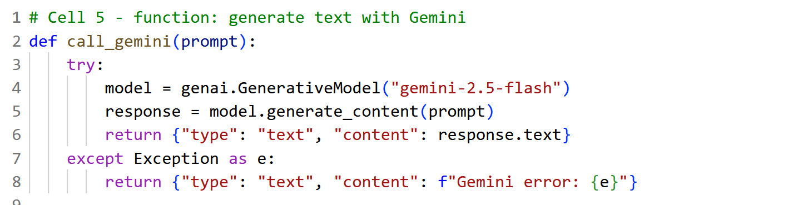
- This function to use and generate the text using Gemini LLM model. I had to use Google Gemini Generative model - “gemini-2.5-flash” instead of “gemini-1.5-flash” – this 1.5 version gives me an error i.e. depreciated model. Moreover, 2.5 – flash version model gives me a response in text form, otherwise it will throw an exception.

10. Intent classifier (simple keyword routing)
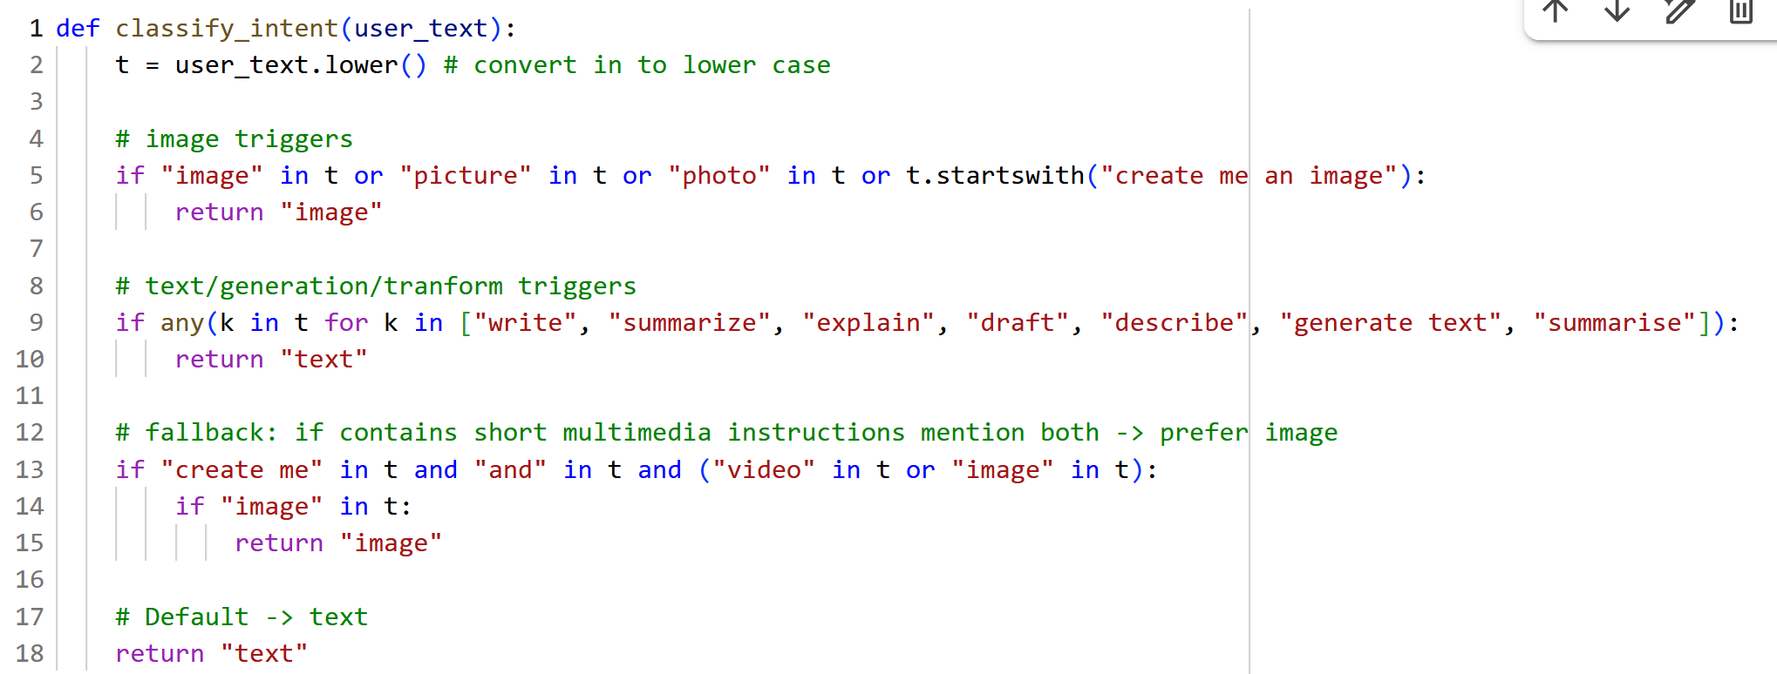
- We created a function classify_intent() which takes user text, then convert the text into lowercase. Similarly, this function used to classify image or text or if it contains short multimedia content then return image. Otherwise by default returns text.
11. Orchestrator: route user requests and call right API
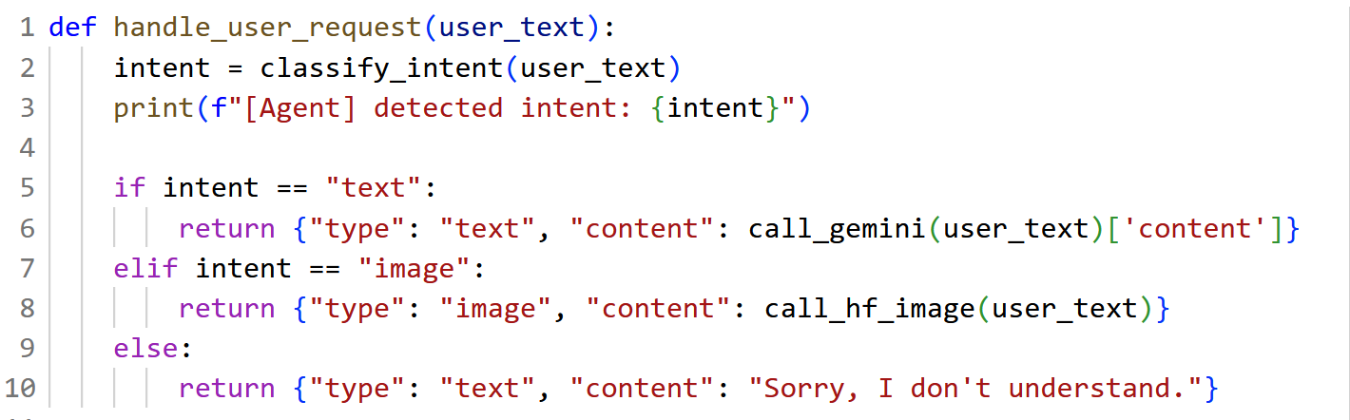
- handle_user_request() used to handle user text and check for classify intent of the given user text if its intention were text it calls the function call_geming() with this function it uses gemini-2.5-flash model and check for the content either it is for text or image if either not return “Sorry, I don’t understand” text.

12. Display image function
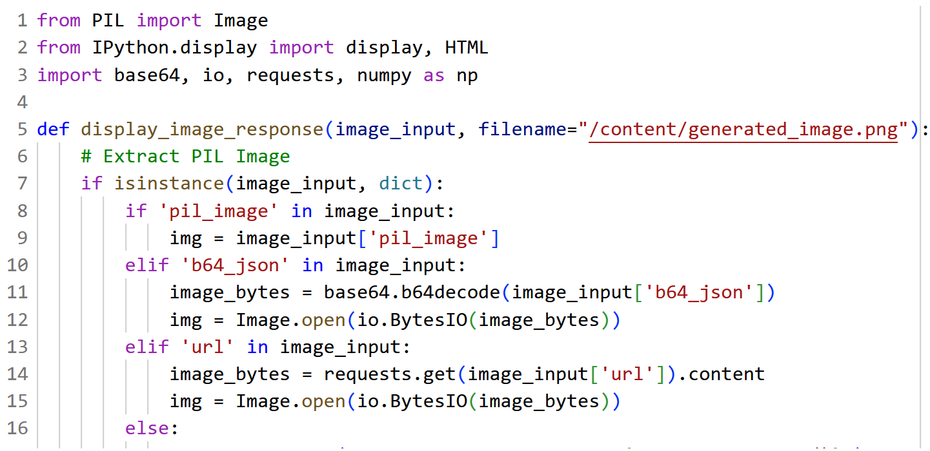
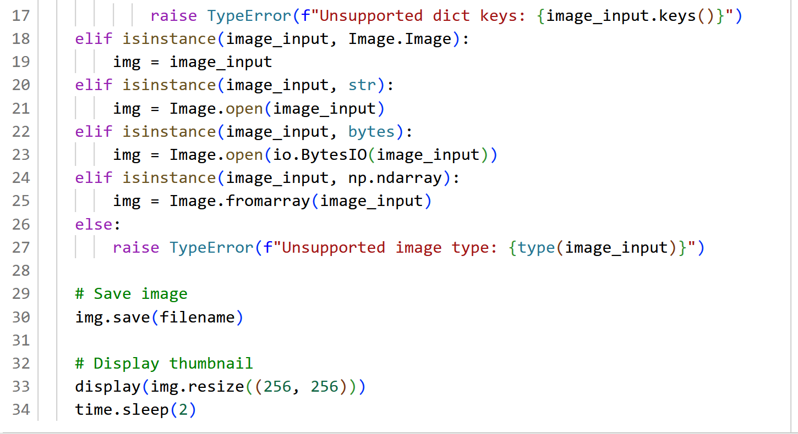
- Here, we created a function display_image_response() to display with a size of 255x255 and save the image locally.
- In this function, we use base64 - Base64 which is a binary-to-text encoding that uses 64 printable characters to represent each 6-bit segment of a sequence of byte values. As for all binary-to-text encodings, Base64-encoding enables transmitting binary data on a communication channel that only supports text.
- And with the help of base64.b64decode () method, we can decode the binary string into normal form.

13. Function to show the text generated by the Gemini model in the wrapped form.
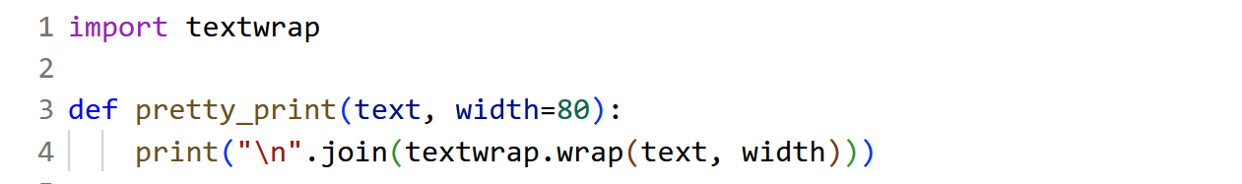
- We use textwrap module for wrapping and formatting of plain text. This module provides formatting of text by adjusting the line breaks in the input paragraph.
14. Code for interactive agent.
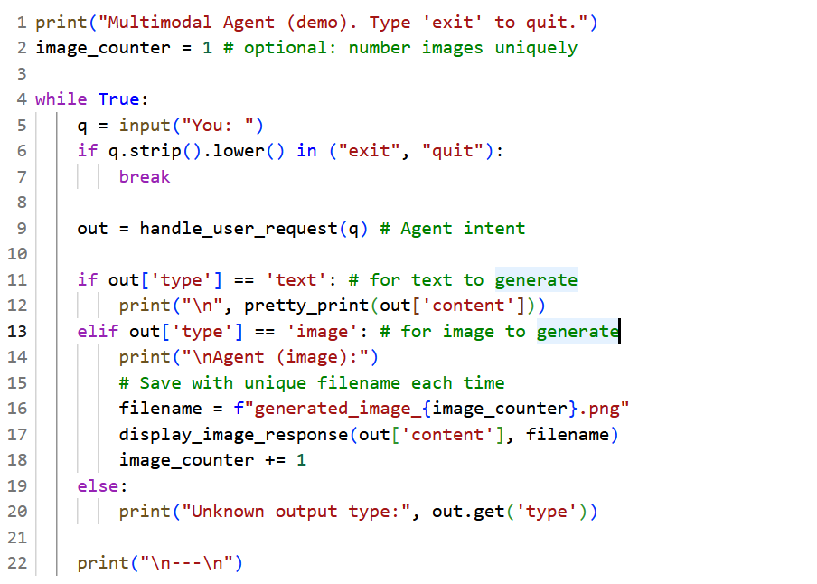
- This code is used for the demonstration of multi-model Agent which is used for the generation of image or text given by the user input or prompt.
15. Output and result of the code.
- When we run the above code, we will witness a prompt to generate image or text output. If we want to exit the prompt, we can enter exit and press enter. To generate the text, include prompt with keywords like “Image”, “photo” etc. for image generation and “describe”, “summarize” etc., as per step 10.

- Prompt1:
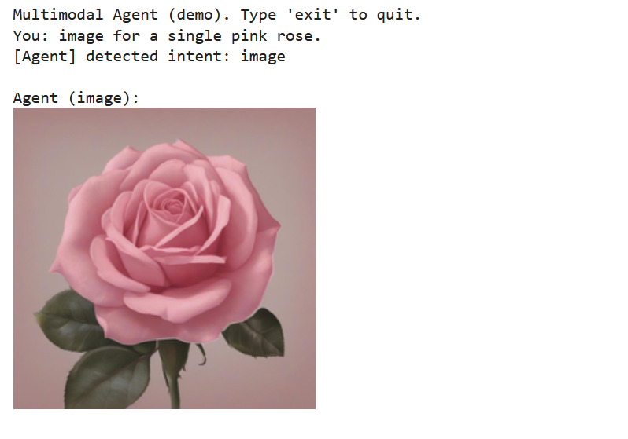
- Prompt 2
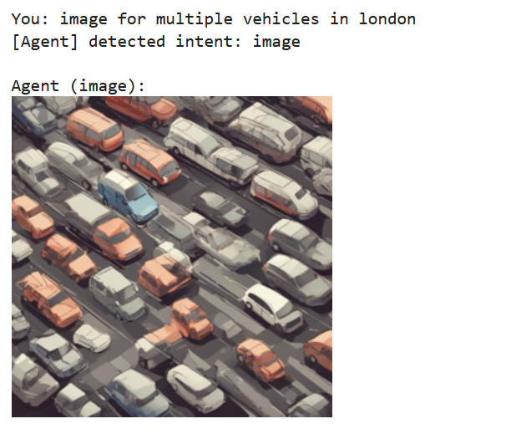

- Prompt 3
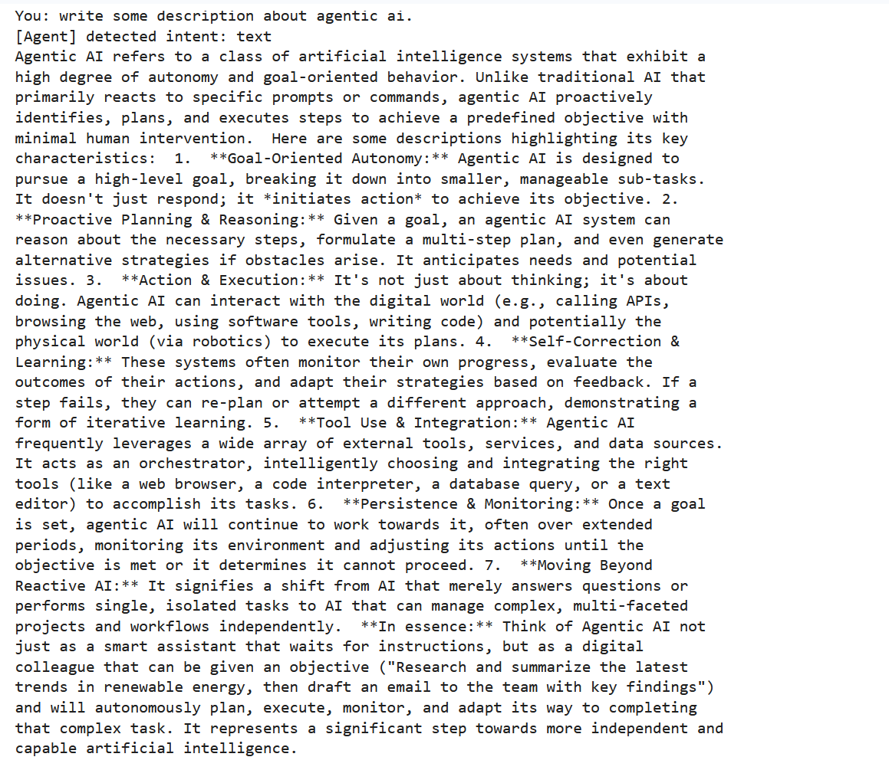
Part II: Learning Objectives
Task 1: Account & API key
- Sign in to Google AI Studio (Gemini developer console).
- Create an API key (Gemini Developer API):
- Open a new Google Colab notebook.
- Install the Google Gen AI SDK + helper libraries.
- arXiv is a free distribution service and an open-access archive for nearly 2.4 million scholarly articles in the fields of physics, mathematics, computer science, quantitative biology, quantitative finance, statistics, electrical engineering and systems science, and economics. Materials on this site are not peer-reviewed by arXiv.
https://arxiv.org/

- Beautiful Soup is a library that makes it easy to scrape information from web pages. It sits atop an HTML or XML parser, providing Pythonic idioms for iterating, searching, and modifying the parse tree.
https://pypi.org/project/beautifulsoup4/
- readability-lxml: Given an HTML document, extract and clean up the main body text and title.

- Securely provide your API key in Colab
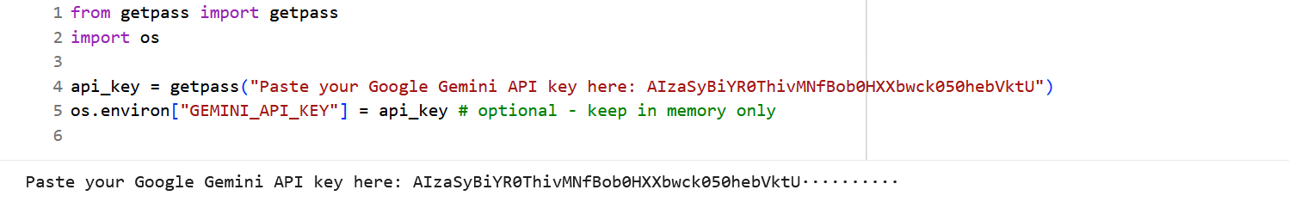
- Initialize the Gen AI client in Colab.
- To initialize the Gen AI client, use the following code
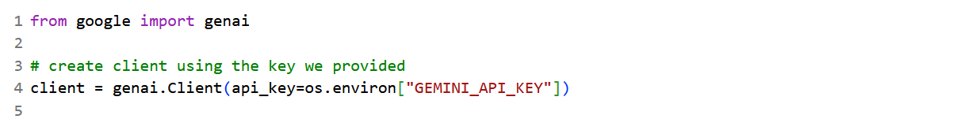
- Try a small generate call to confirm connectivity.
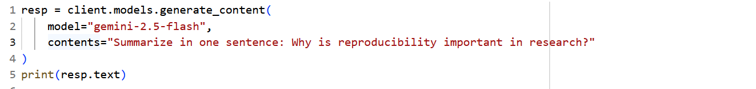
- I will be using “gemini-2.5-flash” model.
- Search arXiv for scholarly papers.
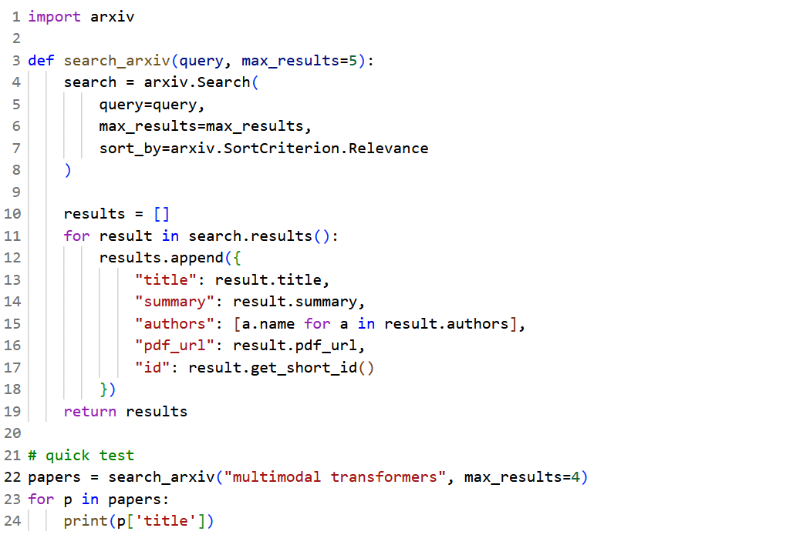

- arXiv: The goal of the API is to allow application developers access to all the arXiv data, search and linking facilities with an easy-to-use programmatic interface. This page provides links to developer documentation and gives instructions for how to join the mailing list and contact other developers and maintainers.

- Grab web-page content for non-paper websites:
- Use requests + BeautifulSoup to extract main paragraphs (simple heuristic)
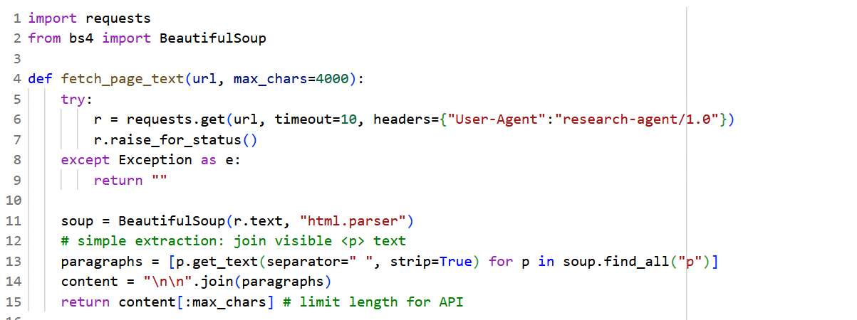
- BeautifulSoup: https://beautiful-soup-4.readthedocs.io/en/latest/
- Prepared Requests: Whenever we receive a Response object from an API call or a Session call, the request attribute is actually the PreparedRequest that was used. In some cases, we may wish to do some extra work to the body or headers (or anything else really) before sending a request.
- We created a fetch_page_text() function with a url and max_char = 4000 as a parameter.

- Create a safe chunking helper (Gemini has big context but chunking helps reliability):
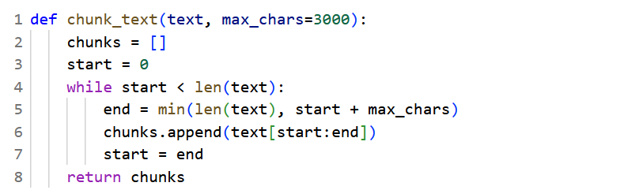
- We created a function chunk_text () to divide a text with maximum characters of 3000 at a time.

- Create a function that asks Gemini to summarize a text chunk.
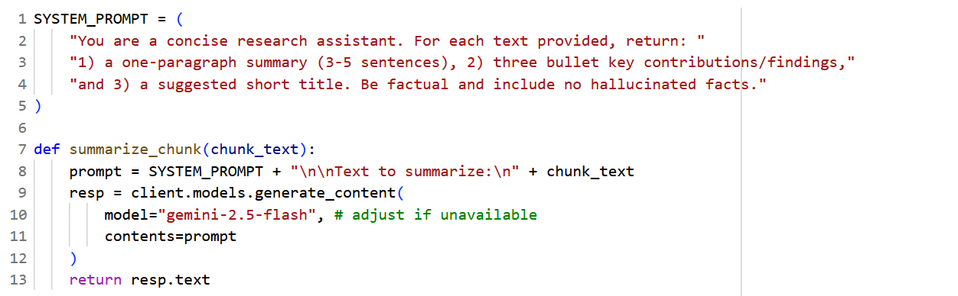
- We keep a short system prompt at the top to set the assistant behaviour.

- Summarize a long document by summarizing chunks + combining.
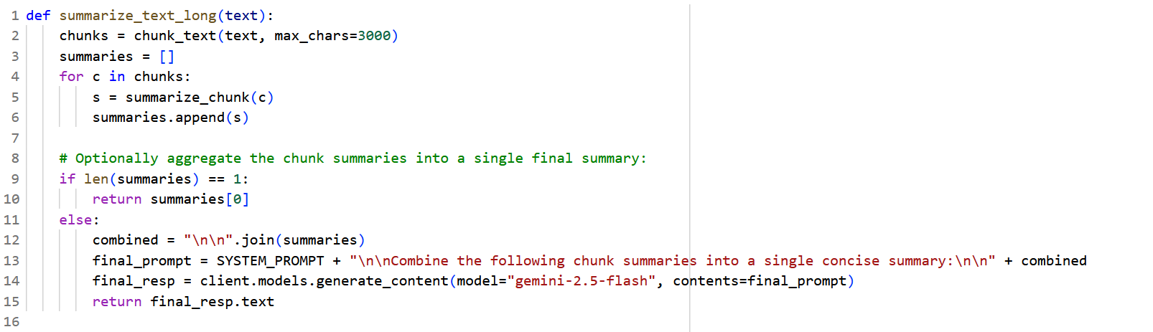
- We create summarize_text_long() to summarize long text from the text and chunk_text with max_character= 3000.

- Putting it together — search and summarize top N arXiv abstracts:
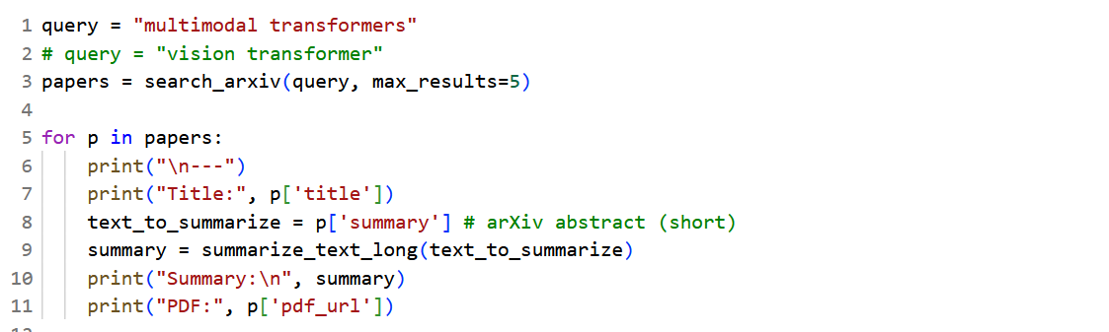
- Write a manual query for any topic. In our case, “multimodal transformer” – this journal will be search through search_arxiv() with maximum result of 5.

Journal 1:
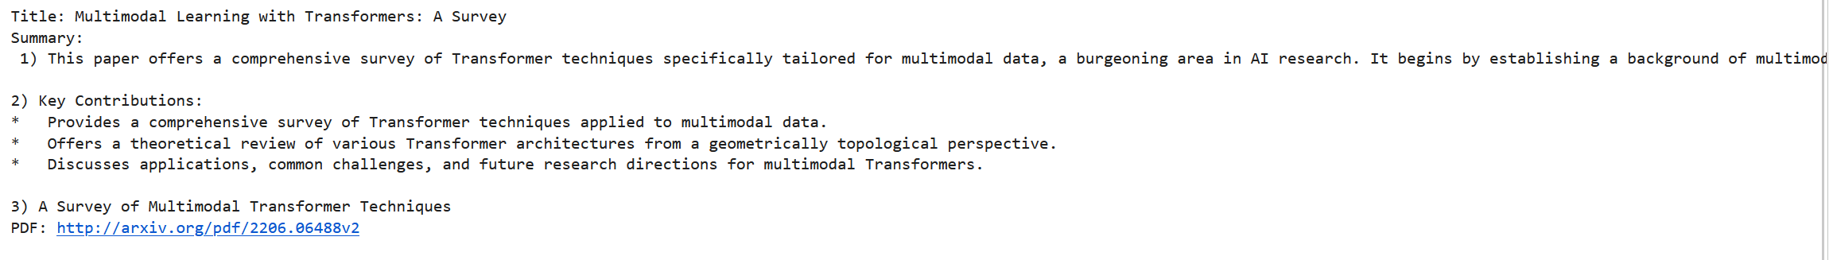
Journal 2:
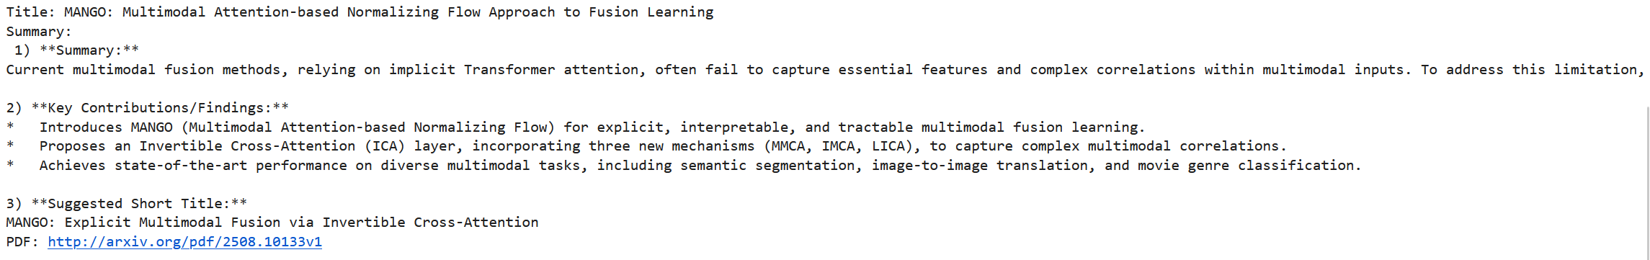
Journal 3:
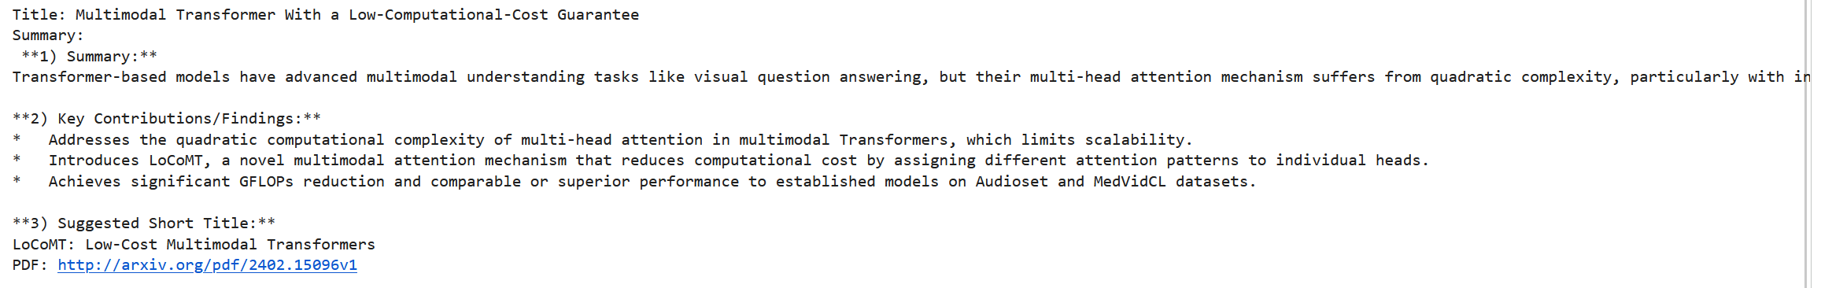
Journal 4
